Task Analysis and Planning to Write

Suggested writing plan:

- Introduction (paraphrase the statement on the question paper to describe what the table and charts show)

- Overview (identify key features i.e. major changes)

- Description of table (detailed information about the table – dates/figures/changes )

- Description of pie charts (detailed information about the pie charts – dates/figures/changes)

Information search

a) What information does the table give?
b) What do the pie charts illustrate?
c) Which years is the data taken from?
d) Which year had the highest number of visitors?
e) Which year had higher levels of visitor satisfaction?
f) What is the difference in the number of people went to the museum before and after it was refurbished?
g) How can you express this change as a percentage or fraction?
h) What proportion of visitors felt very satisfied or satisfied before and after the renovations?
i) How many people were dissatisfied or very dissatisfied before and after the improvements?
j) What proportion of visitors did not respond to the survey in both years?

Resource 3A

Group Writing

Work in a small group. Use the results from the information search to help you fill in the gaps below and write an answer to the task.

The table gives while the pie charts . The statistics .

It is noticeable that

and .

Looking at the figures in the table,

. This is .
Turning to the pie charts,

.

Conversely,

. Finally,
.

Resource 3B

Partially Jumbled Text

In the model answer below, nine parts of the text have been jumbled. Put the words in the correct order.
The table gives information about the number of visitors to Ashdown Museum ¹ illustrate level of charts while the pie the visitor satisfaction. ² from and are before the the statistics taken The years after refurbishment of the museum.

It is noticeable that in the year following ³ to people went museum more improvements the the
and they generally ⁴ felt their after satisfied more visit.

Looking at the figures in the table, visitor ⁵ 92,000 after went up the to from numbers 74,000
renovations. This is a significant increase of 18,000, or just under 25 %.

Turning ⁶ to that see it felt pie is who the very charts, interesting visitors to satisfied or satisfied ⁷ from it considerably before refurbished rose 45% was to 75% after. Conversely, the proportion of those who were dissatisfied or very dissatisfied more ⁸ changes from to the before 50% than 20% halved, after. Finally, the proportion of visitors who did ⁹ remained the to at respond unchanged not survey just 5% in both years.

163 words

1) illustrate level of charts while the pie the visitor
2) from and are before the the statistics taken The years
3) to people went museum more improvements the the
4) felt their after satisfied more
5) 92,000 after went up the to from numbers 74,000
6) to that see it felt pie is who the very charts, interesting visitors to
7) from it considerably before refurbished rose 45% was to 75%
8) changes from to the before 50% than 20% halved,
9) remained the to at respond unchanged not survey

Resource 4

Model Answer Strips

The table gives information about the number of visitors to Ashdown Museum while the pie charts illustrate the level of visitor satisfaction. (E)
The statistics are taken from the years before and after the refurbishment of the museum. (C)
It is noticeable that in the year following the improvements more people went to the museum and they generally felt more satisfied after their visit. (G)
Looking at the figures in the table, visitor numbers went up from 74,000 to 92,000 after the renovations. (H)
This is a significant increase of 18,000, or just under 25%. (B)
Turning to the pie charts, it is interesting to see that visitors who felt very satisfied or satisfied rose considerably from 45% before it was refurbished to 75% after. (F)
Conversely, the proportion of those who were dissatisfied or very dissatisfied more than halved, from 50% before the changes to 20% after. (A)
Finally, the proportion of visitors who did not respond to the survey remained unchanged at just 5% in both years. (D)

Resource 5

Text Analysis

- How many paragraphs are there?

- How many sentences are there in each paragraph?

- Which sentence paraphrases the statement given in the task outline on the question paper?

- What tense is used in the introduction? Why?

- What other information might you need to include in the introduction?

- What tense is used to describe the figures in the table and charts? Why?

- Which paragraph is a summary of the key features of the data with no statistics?

- Which paragraphs contain statistics?

- Are all of the figures accurate?

- What language is used to show comparisons?

- Which phrase informs us that a figure is not exact?

- How many synonyms are used for ‘refurbished’? What are the synonyms?

- Does the answer use a variety of sentence structures and linking devices?

- Is the answer organised logically and is it easy to read and understand?

- What band score would you award this answer? Why?

Resource 6

Synonyms

Look at the twelve words and phrases that are underlined in the text. Can you think of alternatives that could be used instead of them without changing the meaning? Write your ideas in the box below the text.

The table ¹ gives information about the number of visitors to Ashdown Museum ² while the pie charts illustrate the level of visitor satisfaction. The statistics are taken from the years before and after the refurbishment of the museum.

It is ³ noticeable that in the ⁴ year following the improvements more people went to the museum and they generally felt more satisfied after their visit.
Looking at the figures in the table, visitor numbers ⁵ went up from 74,000 to 92,000 after the renovations. This is a ⁶ significant increase of 18,000, or ⁷ just under 25%.

8 Turning to the pie charts, it is interesting to see that visitors who felt very satisfied or satisfied rose considerably from 45% before it was refurbished to 75% after.⁹ Conversely, the proportion of those who were dissatisfied or very dissatisfied more than halved, from 50% before the changes to 20% after. Finally, the ¹⁰ proportion of visitors who did not ¹¹ respond to the survey ¹² remained unchanged at just 5% in both years.

163 words

Possible synonyms:

1. | 2.
3. | 4.
5. | 6.
7. | 8.
9. | 10.
11. | 12.

Test 4

WRITING

WRITING TASK 1

You should spend about 20 minutes on this task.
The table below shows the numbers of visitors to Ashdown Museum during the year before and the year after it was refurbished. The charts show the result of surveys asking visitors how satisfied they were with their visit, during the same two periods.

Summarise the information by selecting and reporting the main features, and make comparisons where relevant.

Write at least 150 words.
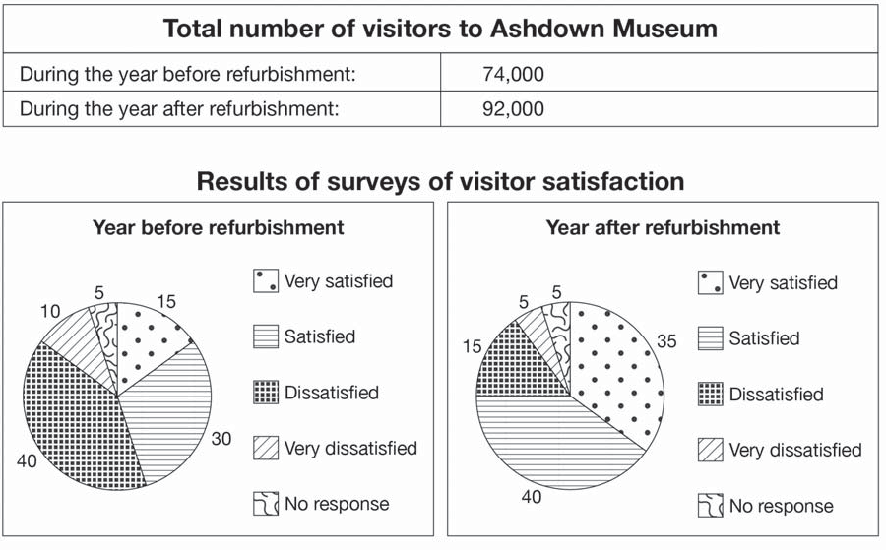

Sample answers for Writing tasks

TEST 4, WRITING TASK 1
SAMPLE ANSWER

This is an answer written by a candidate who achieved a Band 7 score. Here is the examiner’s comment:

The candidate covers the main features of the table and charts, and gives a satisfactory overview of the data. The information is logically organised with a clear progression in the way points are presented. Cohesive devices are used
effectively (during the same two periods), but not always accurately (on a contrary). A range of vocabulary is used flexibly (shows a negative pattern, illustrates that,
an upward trend, has reached its aim), but there are occasional errors in word choice (the amount of visitors, It is obviously). The candidate has used a variety of complex structures (the charts that show the result of surveys asking people how satisfied they were with their visit, after the refurbishment from 74,000 before the reconstruction to 92,000 after it had been done). There is good control of grammar, although there are a few minor errors (there is the charts). Punctuation is generally well controlled, but full stops are missing at the end of the first and final paragraphs and there are a few minor errors (lets look).

The table below shows the amount of visitors to Ashdown Museum during the years after and the year before it was modernized. After the table there is the charts that show the result of surveys asking people how satisﬁed they were with their visit thos museum, during the same two periods
It is obviously that the numbers of visitors signiﬁcantly increased after the refurbishment from 74,000 before the reconstruction to 92,000 after it had been done. Now let’s look at the charts. The year before refurbishment shows a negative pattern: the results of survey illustrate that only 15% of visitors were very satisﬁed and the number of dissatisﬁed people was 40%. The year after refurbishment illustrates that the number of dissatisﬁed visitors declined and became 15%, on a contrary, people who were very satisﬁed increased to 35%. Comparing the amount of satisﬁed visitors we can also see an upward trend (it increased from 30% to 40% after the refurbishment).
To sum up, we can say that all work that has been done to attract new visitors to Ashdown Museum has reached its aim

